

CHALLENGE NAME: [QuadRant]   
DEV: [Utkarsh Shirsath]

CATEGORY: [Steganography]   
LEVEL: [Easy]

2025



CHALLENGE NAME: [QuadRant]

**Challenge Description:**

Four pieces of a forgotten code lie before you. Each fragment holds a part of a greater whole, but the puzzle is incomplete. Your task: find the pattern, align the pieces, and unlock the final code. Once the pieces fall into place, scan what you’ve created to uncover the secret within.

Let the search begin.

**Solution:**

**Step 1: -** Download and extract the zip file. This will give you 4 png files.

**Step 2: -** It is pretty obvious from seeing the 4 images that they are incomplete QR codes and the description tells us to piece them together.

While there are many ways to go about it and many more software both online and offline here is how I did it.

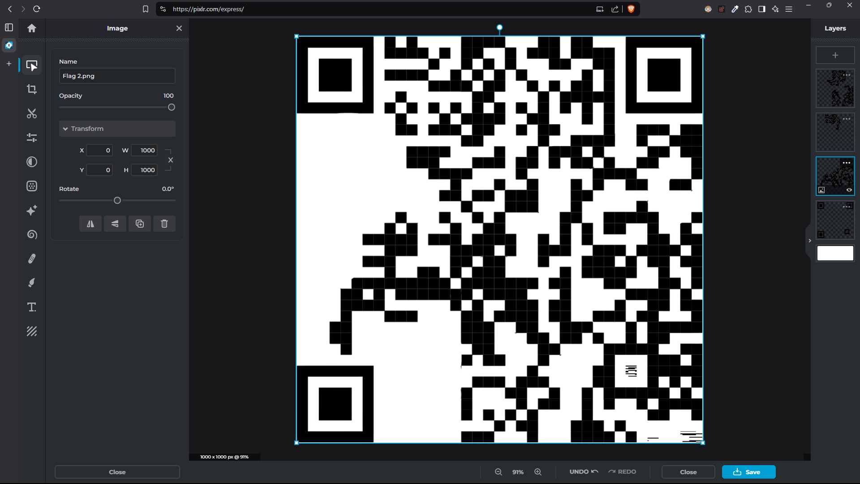

**Website link : -** [**https://pixlr.com/express/**](https://pixlr.com/express/)

Just upload all the 4 images and set the background to white.

Now, Just scan the QR Code and you have the flag

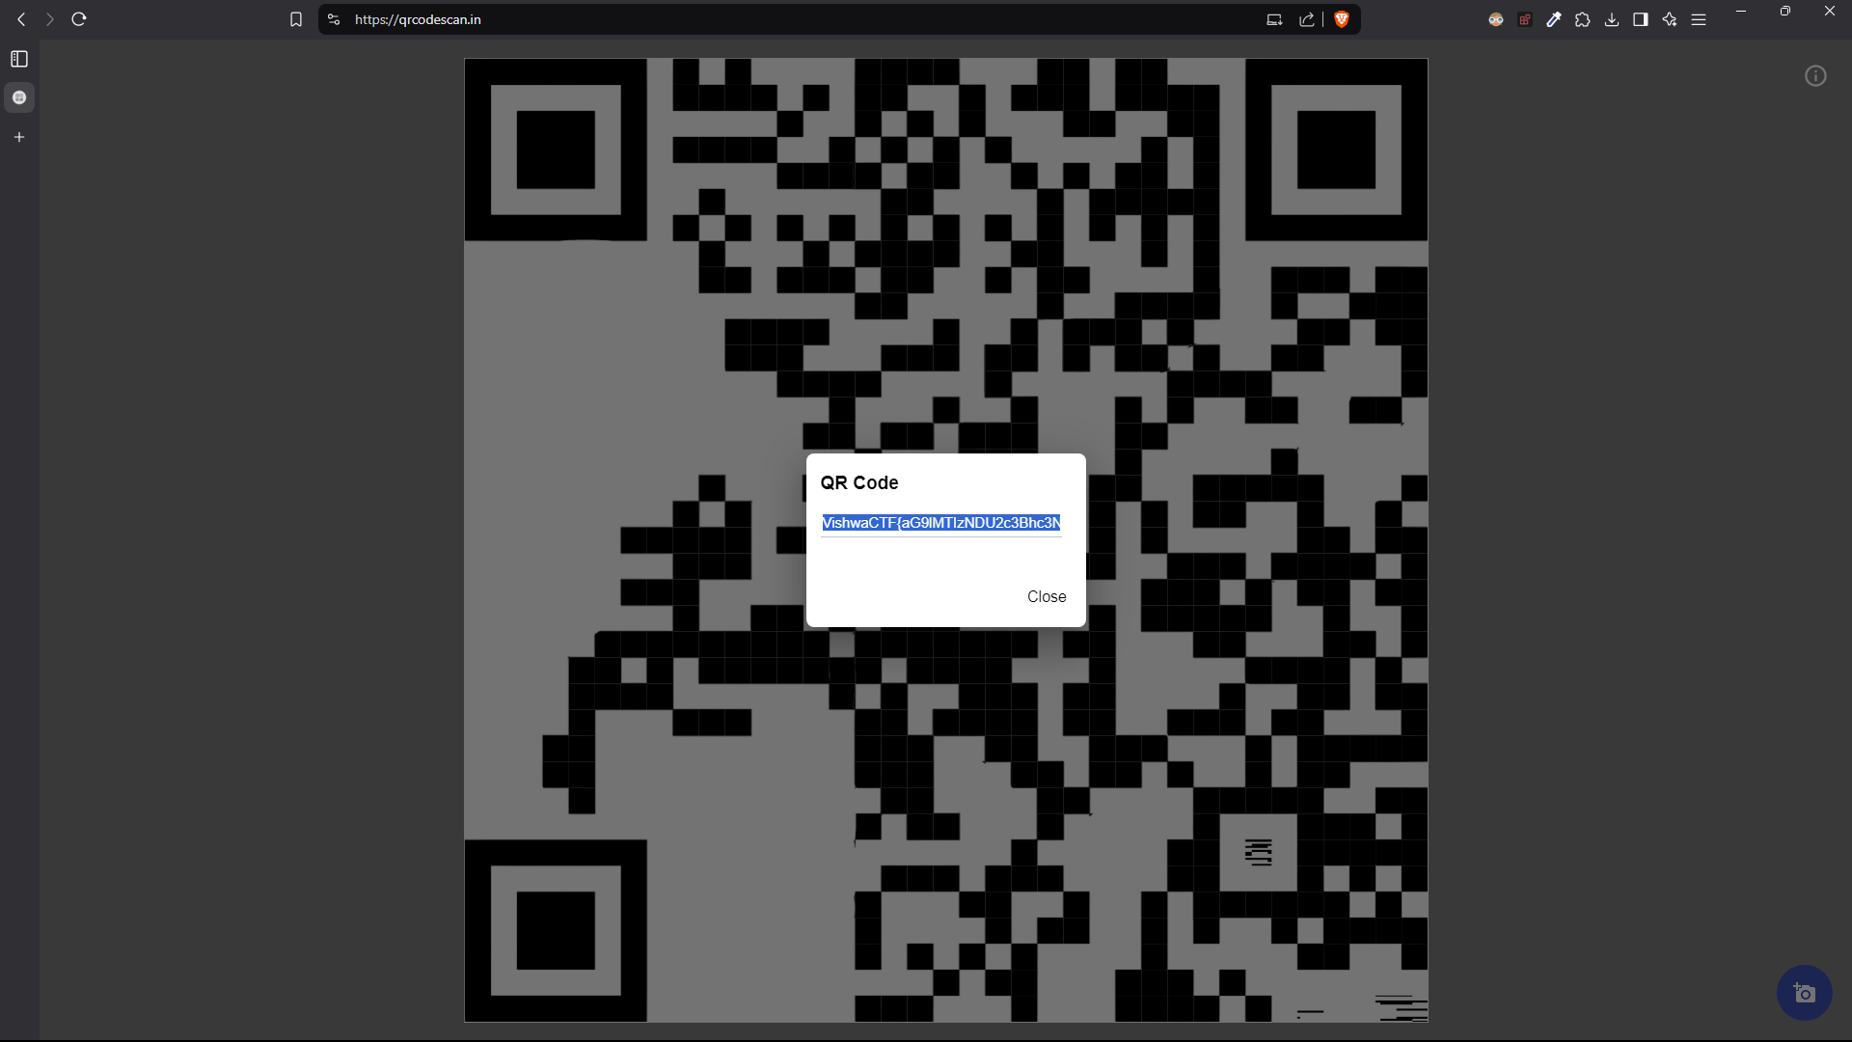

**Website link : -** [**https://qrcodescan.in/**](https://qrcodescan.in/)

**Flag:** VishwaCTF{aG9lMTIzNDU2c3Bhc3NhZ2U=}

DEV: [] **1**